PROJECT REPORT

ADVANCED JAVA PROGRAMMING

CSN302



Session :2025-26

Topic: Expense Tracker App

Submitted to: Submitted by:
Mr. Anuj Kumar Prachi Negi 1000020357
Assistant Professor Manish Mahara 10000202306
School of Computing Vipul Pokhriyal 10000252
DIT University Utkarsh 1000020317

CONTENT

Sr.no | Topic
1. | Acknowledgement
2. | Introduction
3. | Modules Used
4. | Technologies Used
5. | Working of the Application
6. | Features Implemented
7. | Future Enhancements
8. | Conclusion
9. | Snapshots

Acknowledgement

We would like to express our sincere gratitude to Mr. Anuj Kumar and DIT University for their invaluable guidance, support, and mentorship throughout the completion of this mini project. Their expertise, insights, and encouragement were instrumental in navigating the complexities of Advance Java Programming, providing us with a comprehensive understanding of advanced concepts, which played a vital role in the successful completion of this project. This accomplishment reflects the supportive academic environment fostered at DIT University, which has been pivotal in refining our skills and preparing us for future professional challenges. Thank you to everyone who contributed to making this project a meaningful and enriching learning experience.

Introduction

The Expense Tracker is a desktop-based financial management application developed to help users effectively monitor and control their daily expenses. In today’s fast-paced world, keeping track of personal finances is essential to maintain financial stability and achieve saving goals. This system provides users with an organized platform to record, categorize, and analyze their income and expenses conveniently.
The main purpose of the Expense Tracker is to give users a clear picture of their financial activities. By entering daily transactions, users can view summaries, track spending trends, and identify areas where they might be overspending. The system helps users make informed financial decisions and develop better budgeting habits.
Designed with a user-friendly graphical interface (GUI) built using Java Swing, the application ensures a smooth and interactive user experience. It includes essential features such as:
- Adding, updating, and deleting expense records
- Viewing all transactions in a structured table format
- Applying filters to view specific date ranges or categories
- Displaying the total expenses and remaining balance
- Supporting light and dark themes for better visual comfort
- Storing all data securely using SQLite database integration
By combining simplicity with functionality, the Expense Tracker acts as a personal finance assistant that encourages financial discipline and awareness. It is an ideal solution for individuals who want to take control of their spending habits and manage their money efficiently.

Modules Used
The Expense Tracker project is divided into several key modules that work together to manage and display user expenses efficiently.
- User Interface Module:
Built using Java Swing, it provides an interactive GUI with buttons, text fields, and tables for adding, viewing, and managing expenses. It also supports light and dark modes for better appearance.
- Database Module:
Uses SQLite to store and retrieve expense records. It handles all database operations like adding, updating, deleting, and fetching data.
- Expense Management Module:
Manages core operations such as adding, editing, deleting, and calculating total expenses, ensuring accurate record handling.
- Report and Summary Module:
Displays expenses in a table and provides summaries such as total or category-wise spending to help users analyze their finances.
- Settings Module:
Allows customization options like theme switching and layout preferences to enhance the user experience.

Technologies Used

Component | Tool/Technology
Programming | Java
GUI | Java Swing and AWT
IDE | VS Code

Working of the Application

Detailed Working of the Expense Tracker Application
1. Overview
The Expense Tracker is a desktop-based financial management system built using Java Swing for the front-end interface and SQLite for the back-end database.
It helps users record, manage, and monitor their daily expenses efficiently through an interactive graphical user interface (GUI).

2. Working of the Application
Step 1: Application Initialization
- When the application is launched, the main frame (JFrame) is created and initialized.
- It sets the layout, title, icon, and theme (Light or Dark Mode using FlatLaf).
- The UI is divided into three main sections:
  - Input Panel – for adding or editing expense data
  - Table Panel – for displaying all records
  - Summary Panel – for total and filter options

3. Database Connection and Setup
- The application uses SQLite for storing expense data locally.
- A database file (expenses.db) is automatically created if it doesn’t exist.
4. GUI Components and Their Functions
A. Input Fields
- Date Field (JTextField or JDateChooser)
  - Used to enter or pick the date of the transaction.
- Category Combo Box (JComboBox)
  - Allows the user to select the type of expense, such as Food, Travel, Bills, Entertainment, etc.
- Description Field (JTextField)
  - User can briefly describe the expense (e.g., “Lunch at cafe”, “Bus fare”).
- Amount Field (JTextField)
  - Used to enter the expense amount. It only accepts numeric input.

B. Buttons and Their Functions
- Add Button
  - Inserts a new record into the database.
  - Performs input validation (e.g., ensures fields aren’t empty and amount is valid).
  - After adding, the table updates automatically.
Update Button
- Updates the details of the selected record in the table.
- The user selects a row, edits the fields, and clicks “Update”.
WHERE id=?;
Delete Button

Deletes the selected record permanently from both the table and database.
- Clear Button
  - Clears all input fields to allow the user to enter new data easily.
  - Does not affect the database.
- Filter/Search Button (optional)
  - Allows filtering records by category, date range, or keyword in the description.
  - Uses SQL WHERE clauses to fetch filtered results.
- Theme Switch Button / Settings Menu
  - Toggles between Light Mode and Dark Mode using FlatLaf themes (FlatLightLaf and FlatDarculaLaf).
  - Changes background and component styles dynamically.
- Exit / Logout Button (optional)
  - Closes the application or logs the user out after saving unsaved changes.

5. Expense Table (JTable)
- Displays all expenses fetched from the database.
- Columns include ID, Date, Category, Description, Amount.
- Automatically refreshes when new data is added or existing data is modified.
- Supports row selection for editing or deleting entries.
- Can be styled with borders, alternating row colors, and font customization.

6. Total and Summary Calculation
- After every database operation, the total amount of all expenses is recalculated.
- The total is displayed at the bottom of the interface in a JLabel.
7. Data Handling and Validation
- Input validation ensures:
  - Amount is numeric
  - Required fields are not empty
  - Invalid or duplicate entries are avoided
- All data modifications immediately reflect in both the UI and database.

8. Optional Features
- Export Data: Save all records to a .csv or .txt file.
- Charts: Visualize expenses by category or date using chart libraries like JFreeChart.
- Authentication (optional): Add login functionality for multi-user access.

9. Required JAR Files
Place the following .jar files inside a folder named lib in your project directory:
JAR File | Purpose
sqlite-jdbc.jar | Provides JDBC driver for SQLite database connection.
flatlaf-3.50.3.jar | Enables modern UI styling and theme support.
flatlaf-intellij-themes-3.6.2.jar (optional) | Adds extra components like icons and fonts.

10. Compilation and Execution Steps
Step 1: Compile
Open Command Prompt in the project directory and type:
Compile Command
javac -cp ".;sqlite-jdbc-3.50.3.0.jar;flatlaf-3.6.2.jar;flatlaf-intellij-themes-3.6.2.jar" ExpenseTracker.java
Run Command
java -cp ".;sqlite-jdbc-3.50.3.0.jar;flatlaf-3.6.2.jar;flatlaf-intellij-themes-3.6.2.jar" ExpenseTracker

11. Output and User Experience
When the application runs:
- The main window appears with input fields, table, and buttons.
- Users can add, update, delete, and view expenses easily.
- The total expense and summary are updated dynamically.
- Data remains saved even after restarting the app (persistent storage in SQLite).
- Users can toggle between light and dark mode for better visibility.

Features Implemented
The Expense Tracker application includes a wide range of features designed to make expense management simple, efficient, and visually appealing. Below is a list of all the main features implemented:

1. User-Friendly Graphical Interface
- Developed using Java Swing, the app provides an intuitive and responsive GUI.
- Organized layout with input fields, buttons, and a table for displaying expenses.
- Includes labels, combo boxes, and panels for smooth navigation and usability.

2. Add New Expenses
- Allows users to enter expense details such as date, category, description, and amount.
- Performs validation to prevent empty or invalid entries.
- Automatically updates the table and database once a new expense is added.

3. Edit and Update Expenses
- Enables users to select any existing record from the table and update its details.
- Changes are immediately reflected in both the UI and the SQLite database.

4. Delete Expenses
- Provides a simple option to delete unwanted expense records permanently.
- Ensures the table and total amount are updated after deletion.

5. Expense Table Display
- Displays all stored records in a structured JTable format.
- Columns include ID, Date, Category, Description, and Amount.
- Supports row selection for editing and deleting entries.
- Automatically refreshes whenever the database changes.

6. Total Expense Calculation
- Continuously calculates and displays the total amount of all expenses.
- Updates automatically after every add, update, or delete operation.

7. Category and Date Filtering (Optional)
- Allows users to filter expenses by specific categories (e.g., Food, Travel, Bills) or by date range.
- Helps users analyze spending patterns efficiently.

8. Theme Customization (Light and Dark Mode)
- Integrated with FlatLaf library to provide modern light and dark themes.
- Enhances user comfort and interface appearance.

9. Data Storage with SQLite Database
- Uses SQLite as a local database for permanent storage of all expenses.
- Automatically creates and manages the database file (expenses.db).
- Performs all CRUD operations (Create, Read, Update, Delete) efficiently.

10. Data Validation
- Ensures that all input fields are properly filled before submission.
- Prevents incorrect or blank data entries (e.g., invalid amount format).

11. Persistent Data
- All records remain saved even after closing the application.
- The database automatically reloads on startup.

12. Clear and Reset Functionality
- Clear button resets all input fields for new data entry without affecting saved records.

13. Attractive and Professional Layout
- Proper alignment, spacing, and styling for a professional look.
- Uses consistent fonts, icons, and colors across all components.

14. Optional Features (Can Be Extended)
- Export data to .csv or .txt file.
- Generate visual reports using charts.
- Add login or user authentication system.

Future Enhancements
Although the current version of the Expense Tracker efficiently manages daily expenses, several features can be added in the future to improve functionality, performance, and user experience.

1. User Login and Authentication
- Introduce a secure login system that allows multiple users to maintain their own separate accounts.
- Add password protection and encryption to ensure data privacy.

2. Data Visualization and Charts
- Integrate charts and graphs (using libraries like JFreeChart) to display spending patterns visually.
- Show monthly, weekly, or category-wise expense analysis using bar, pie, or line charts.

3. Income and Budget Management
- Add features to record income sources and set monthly budgets.
- Alert users when spending exceeds their budget limit.

4. Export and Import Options
- Allow users to export their expense data to formats like CSV, Excel, or PDF for backup or sharing.
- Enable importing existing data files back into the application.

5. Cloud Synchronization
- Store user data in the cloud to allow access from multiple devices.
- Synchronize records automatically when connected to the internet.

6. Advanced Search and Filter
- Implement advanced filtering by date range, amount range, or keyword.
- Add sorting options (e.g., highest to lowest expense, newest to oldest).

7. Mobile and Web Versions
- Develop a mobile app or web-based version for better accessibility.
- Ensure cross-platform compatibility so users can track expenses anytime, anywhere.

8. Notification and Reminder System
- Send reminders for recurring expenses or bills.
- Notify users when expenses reach a certain threshold.

9. Category Customization
- Allow users to add, rename, or delete categories based on personal preference.

10. AI-Based Expense Insights (Advanced Feature)
- Use machine learning to analyze user spending habits and give personalized suggestions for saving money.

- Code - import java.awt.*;
- import java.awt.event.*;
- import java.io.*;
- import java.sql.*;
- import javax.swing.*;
- import javax.swing.border.*;
- import javax.swing.table.DefaultTableModel;
- import org.sqlite.SQLiteDataSource;
- import com.formdev.flatlaf.FlatDarculaLaf;
- import com.formdev.flatlaf.FlatLightLaf;

- public class ExpenseTracker {
- private static Connection conn;
- private static SQLiteDataSource ds;
- private JFrame frame;
- private JTable table;
- private JTextField dateField, descField, amountField, nameField;
- private int currentAccountId = 0;
- private JLabel lblTotalValue;
- private JComboBox<String> accBox;
- private boolean darkMode = false;

- public static void main(String[] args) {
- EventQueue.invokeLater(() -> {
- try {
- new ExpenseTracker().frame.setVisible(true);
- } catch (Exception e) {
- e.printStackTrace();
- }
- });
- }

- public ExpenseTracker() {
- loadThemePreference();
- setLookAndFeel();
- initDB();
- initialize();
- }

- // === THEME HANDLING ===
- private void loadThemePreference() {
- try (BufferedReader br = new BufferedReader(new FileReader("theme.txt"))) {
- darkMode = "dark".equalsIgnoreCase(br.readLine());
- } catch (IOException ignored) {}
- }

- private void saveThemePreference() {
- try (BufferedWriter bw = new BufferedWriter(new FileWriter("theme.txt"))) {
- bw.write(darkMode ? "dark" : "light");
- } catch (IOException ignored) {}
- }

- private void setLookAndFeel() {
- try {
- if (darkMode) {
- UIManager.setLookAndFeel(new FlatDarculaLaf());
- } else {
- try {
- UIManager.setLookAndFeel("com.formdev.flatlaf.intellijthemes.FlatArcOrangeIJTheme");
- } catch (Exception e) {
- UIManager.setLookAndFeel(new FlatLightLaf());
- }
- }
- } catch (Exception e) {
- e.printStackTrace();
- }
- }

- // === DATABASE INITIALIZATION ===
- private void initDB() {
- ds = new SQLiteDataSource();
- try {
- ds.setUrl("jdbc:sqlite:ExpensesDB.db");
- conn = ds.getConnection();
- Statement stmt = conn.createStatement();
- stmt.executeUpdate("CREATE TABLE IF NOT EXISTS accounts (id INTEGER PRIMARY KEY AUTOINCREMENT, name TEXT)");
- stmt.executeUpdate("CREATE TABLE IF NOT EXISTS expenses (id INTEGER PRIMARY KEY AUTOINCREMENT, account_id INTEGER, date TEXT, description TEXT, amount REAL, FOREIGN KEY (account_id) REFERENCES accounts(id))");
- stmt.close();
- conn.close();
- } catch (SQLException e) {
- JOptionPane.showMessageDialog(null, "Database initialization failed: " + e.getMessage());
- }
- }

- // === MAIN INTERFACE ===
- private void initialize() {
- frame = new JFrame("💼 Expense Tracker Pro");
- frame.setDefaultCloseOperation(JFrame.EXIT_ON_CLOSE);
- frame.setSize(1000, 650);
- frame.setLocationRelativeTo(null);

- JPanel background = new JPanel(new BorderLayout(15, 15)) {
- @Override
- protected void paintComponent(Graphics g) {
- super.paintComponent(g);
- Graphics2D g2 = (Graphics2D) g;
- if (darkMode) {
- g2.setPaint(new GradientPaint(0, 0, new Color(30, 30, 35), getWidth(), getHeight(), new Color(50, 50, 55)));
- } else {
- g2.setPaint(new GradientPaint(0, 0, new Color(245, 247, 255), getWidth(), getHeight(), new Color(225, 230, 245)));
- }
- g2.fillRect(0, 0, getWidth(), getHeight());
- }
- };
- background.setBorder(new EmptyBorder(15, 15, 15, 15));
- frame.setContentPane(background);

- // === HEADER BAR ===
- JPanel header = new JPanel(new BorderLayout(15, 15)) {
- @Override
- protected void paintComponent(Graphics g) {
- super.paintComponent(g);
- Graphics2D g2 = (Graphics2D) g;
- g2.setRenderingHint(RenderingHints.KEY_ANTIALIASING, RenderingHints.VALUE_ANTIALIAS_ON);
- Color c1 = darkMode ? new Color(60, 70, 90) : new Color(70, 110, 250);
- Color c2 = darkMode ? new Color(40, 45, 60) : new Color(140, 70, 255);
- GradientPaint gp = new GradientPaint(0, 0, c1, getWidth(), getHeight(), c2);
- g2.setPaint(gp);
- g2.fillRoundRect(0, 0, getWidth(), getHeight(), 15, 15);
- }
- };
- header.setBorder(new EmptyBorder(12, 20, 12, 20));

- JPanel titlePanel = new JPanel(new FlowLayout(FlowLayout.LEFT, 10, 0));
- titlePanel.setOpaque(false);
- JLabel logo = new JLabel(new ImageIcon("logo.png"));
- JLabel title = new JLabel("Expense Tracker Pro");
- title.setFont(new Font("Segoe UI Semibold", Font.BOLD, 22));
- title.setForeground(Color.WHITE);
- titlePanel.add(logo);
- titlePanel.add(title);

- JButton themeToggle = new JButton(darkMode ? "☀ Light Mode" : "🌙 Dark Mode");
- themeToggle.setFocusPainted(false);
- themeToggle.setForeground(Color.WHITE);
- themeToggle.setBackground(new Color(255, 255, 255, 40));
- themeToggle.setFont(new Font("Segoe UI", Font.PLAIN, 13));
- themeToggle.setBorder(new RoundedBorder(10));
- themeToggle.setPreferredSize(new Dimension(140, 35));
- themeToggle.addActionListener(e -> toggleTheme());

- header.add(titlePanel, BorderLayout.WEST);
- header.add(themeToggle, BorderLayout.EAST);
- background.add(header, BorderLayout.NORTH);

- // === SIDEBAR ===
- JPanel sidebar = new JPanel(new GridBagLayout());
- sidebar.setOpaque(false);
- sidebar.setBorder(BorderFactory.createTitledBorder(
- BorderFactory.createLineBorder(new Color(180, 180, 180)),
- "Accounts", TitledBorder.LEADING, TitledBorder.TOP, new Font("Segoe UI", Font.BOLD, 14)
- ));
- sidebar.setPreferredSize(new Dimension(260, 0));

- GridBagConstraints gbc = new GridBagConstraints();
- gbc.insets = new Insets(8, 12, 8, 12);
- gbc.fill = GridBagConstraints.HORIZONTAL;

- accBox = new JComboBox<>();
- nameField = new JTextField();
- JButton btnAddAcc = new JButton("➕ Add Account");
- JButton btnDeleteAcc = new JButton("🗑 Delete Account");
- JButton btnSelectAcc = new JButton("✅ Select");
- JButton btnReceipt = new JButton("🧾 Generate Receipt");

- int y = 0;
- gbc.gridx = 0; gbc.gridy = y++; sidebar.add(new JLabel("Select Account:"), gbc);
- gbc.gridy = y++; sidebar.add(accBox, gbc);
- gbc.gridy = y++; sidebar.add(new JLabel("New Account:"), gbc);
- gbc.gridy = y++; sidebar.add(nameField, gbc);
- gbc.gridy = y++; sidebar.add(btnAddAcc, gbc);
- gbc.gridy = y++; sidebar.add(btnDeleteAcc, gbc);
- gbc.gridy = y++; sidebar.add(btnSelectAcc, gbc);
- gbc.gridy = y++; sidebar.add(btnReceipt, gbc);

- // === MAIN TABLE AREA ===
- JPanel mainPanel = new JPanel(new BorderLayout(10, 10));
- mainPanel.setOpaque(false);
- mainPanel.setBorder(BorderFactory.createTitledBorder(
- BorderFactory.createLineBorder(new Color(180, 180, 180)),
- "Expenses", TitledBorder.LEADING, TitledBorder.TOP, new Font("Segoe UI", Font.BOLD, 14)
- ));

- table = new JTable(new DefaultTableModel(new Object[]{"Date", "Description", "Amount"}, 0));
- table.setRowHeight(26);
- table.setFont(new Font("Segoe UI", Font.PLAIN, 13));
- table.getTableHeader().setFont(new Font("Segoe UI Semibold", Font.PLAIN, 13));
- JScrollPane scrollPane = new JScrollPane(table);
- scrollPane.setBorder(BorderFactory.createLineBorder(new Color(200, 200, 200)));
- mainPanel.add(scrollPane, BorderLayout.CENTER);

- // === BOTTOM BAR ===
- JPanel bottomPanel = new JPanel(new GridBagLayout());
- bottomPanel.setOpaque(false);
- bottomPanel.setBorder(new EmptyBorder(10, 10, 10, 10));
- GridBagConstraints c = new GridBagConstraints();
- c.insets = new Insets(6, 8, 6, 8);
- c.fill = GridBagConstraints.HORIZONTAL;

- dateField = new JTextField(10);
- descField = new JTextField(15);
- amountField = new JTextField(10);
- JButton btnAddExp = new JButton("💰 Add Expense");
- JButton btnDeleteExp = new JButton("🗑 Delete Selected");
- lblTotalValue = new JLabel("0.00");
- lblTotalValue.setFont(new Font("Segoe UI", Font.BOLD, 16));

- c.gridx = 0; bottomPanel.add(new JLabel("Date:"), c);
- c.gridx = 1; bottomPanel.add(dateField, c);
- c.gridx = 2; bottomPanel.add(new JLabel("Description:"), c);
- c.gridx = 3; bottomPanel.add(descField, c);
- c.gridx = 4; bottomPanel.add(new JLabel("Amount:"), c);
- c.gridx = 5; bottomPanel.add(amountField, c);
- c.gridx = 6; bottomPanel.add(btnAddExp, c);
- c.gridx = 7; bottomPanel.add(btnDeleteExp, c);
- c.gridx = 8; bottomPanel.add(new JLabel("Total:"), c);
- c.gridx = 9; bottomPanel.add(lblTotalValue, c);

- mainPanel.add(bottomPanel, BorderLayout.SOUTH);

- background.add(sidebar, BorderLayout.WEST);
- background.add(mainPanel, BorderLayout.CENTER);

- // === ACTIONS ===
- btnAddAcc.addActionListener(e -> { addAccount(nameField.getText()); refreshAccounts(); nameField.setText(""); });
- btnDeleteAcc.addActionListener(e -> deleteAccountAction());
- btnSelectAcc.addActionListener(e -> selectAccount());
- btnAddExp.addActionListener(e -> addExpenseAction());
- btnDeleteExp.addActionListener(e -> deleteSelectedExpense());
- btnReceipt.addActionListener(e -> generateReceipt());

- refreshAccounts();
- }

- // === UTILITY CLASSES ===
- private static class RoundedBorder extends AbstractBorder {
- private final int radius;
- RoundedBorder(int radius) { this.radius = radius; }
- @Override public void paintBorder(Component c, Graphics g, int x, int y, int w, int h) {
- Graphics2D g2 = (Graphics2D) g;
- g2.setRenderingHint(RenderingHints.KEY_ANTIALIASING, RenderingHints.VALUE_ANTIALIAS_ON);
- g2.setColor(new Color(255, 255, 255, 100));
- g2.drawRoundRect(x, y, w - 1, h - 1, radius, radius);
- }
- }

- // === LOGIC ===
- private void toggleTheme() {
- darkMode = !darkMode;
- saveThemePreference();
- frame.dispose();
- SwingUtilities.invokeLater(() -> new ExpenseTracker().frame.setVisible(true));
- }

- private void refreshAccounts() {
- try {
- accBox.removeAllItems();
- conn = ds.getConnection();
- ResultSet rs = conn.createStatement().executeQuery("SELECT * FROM accounts");
- while (rs.next()) accBox.addItem(rs.getInt("id") + "|" + rs.getString("name"));
- conn.close();
- } catch (SQLException e) {
- JOptionPane.showMessageDialog(frame, e.getMessage());
- }
- }

- private void selectAccount() {
- String selected = (String) accBox.getSelectedItem();
- if (selected == null) return;
- currentAccountId = Integer.parseInt(selected.split("\\|")[0]);
- refreshExpenses();
- }

- private void addAccount(String name) {
- if (name.isBlank()) {
- JOptionPane.showMessageDialog(frame, "Account name cannot be empty.");
- return;
- }
- try {
- conn = ds.getConnection();
- PreparedStatement ps = conn.prepareStatement("INSERT INTO accounts (name) VALUES (?)");
- ps.setString(1, name);
- ps.executeUpdate();
- conn.close();
- } catch (SQLException e) {
- JOptionPane.showMessageDialog(frame, e.getMessage());
- }
- }

- private void deleteAccountAction() {
- String selected = (String) accBox.getSelectedItem();
- if (selected == null) return;
- int id = Integer.parseInt(selected.split("\\|")[0]);
- int confirm = JOptionPane.showConfirmDialog(frame, "Delete this account and all expenses?", "Confirm", JOptionPane.YES_NO_OPTION);
- if (confirm == JOptionPane.YES_OPTION) deleteAccount(id);
- }

- private void deleteAccount(int id) {
- try {
- conn = ds.getConnection();
- conn.createStatement().executeUpdate("DELETE FROM expenses WHERE account_id=" + id);
- conn.createStatement().executeUpdate("DELETE FROM accounts WHERE id=" + id);
- conn.close();
- ((DefaultTableModel) table.getModel()).setRowCount(0);
- lblTotalValue.setText("0.00");
- currentAccountId = 0;
- refreshAccounts();
- } catch (SQLException e) {
- JOptionPane.showMessageDialog(frame, e.getMessage());
- }
- }

- private void addExpenseAction() {
- try {
- addExpense(currentAccountId, dateField.getText(), descField.getText(), Double.parseDouble(amountField.getText()));
- dateField.setText(""); descField.setText(""); amountField.setText("");
- refreshExpenses();
- } catch (Exception ex) {
- JOptionPane.showMessageDialog(frame, "Error: " + ex.getMessage());
- }
- }

- private void addExpense(int accId, String date, String desc, double amount) throws SQLException {
- if (accId == 0) throw new SQLException("No account selected");
- conn = ds.getConnection();
- PreparedStatement ps = conn.prepareStatement("INSERT INTO expenses (account_id, date, description, amount) VALUES (?, ?, ?, ?)");
- ps.setInt(1, accId);
- ps.setString(2, date);
- ps.setString(3, desc);
- ps.setDouble(4, amount);
- ps.executeUpdate();
- conn.close();
- }

- private void refreshExpenses() {
- try {
- DefaultTableModel model = (DefaultTableModel) table.getModel();
- model.setRowCount(0);
- double total = 0;
- conn = ds.getConnection();
- PreparedStatement ps = conn.prepareStatement("SELECT date, description, amount FROM expenses WHERE account_id=?");
- ps.setInt(1, currentAccountId);
- ResultSet rs = ps.executeQuery();
- while (rs.next()) {
- model.addRow(new Object[]{rs.getString(1), rs.getString(2), rs.getDouble(3)});
- total += rs.getDouble(3);
- }
- lblTotalValue.setText(String.format("%.2f", total));
- conn.close();
- } catch (SQLException e) {
- JOptionPane.showMessageDialog(frame, e.getMessage());
- }
- }

- private void deleteSelectedExpense() {
- int row = table.getSelectedRow();
- if (row == -1) {
- JOptionPane.showMessageDialog(frame, "Select an expense to delete.");
- return;
- }
- String date = (String) table.getValueAt(row, 0);
- String desc = (String) table.getValueAt(row, 1);
- double amt = (double) table.getValueAt(row, 2);
- try {
- conn = ds.getConnection();
- PreparedStatement ps = conn.prepareStatement("DELETE FROM expenses WHERE account_id=? AND date=? AND description=? AND amount=?");
- ps.setInt(1, currentAccountId);
- ps.setString(2, date);
- ps.setString(3, desc);
- ps.setDouble(4, amt);
- ps.executeUpdate();
- conn.close();
- refreshExpenses();
- } catch (SQLException e) {
- JOptionPane.showMessageDialog(frame, e.getMessage());
- }
- }

- // === GENERATE RECEIPT FEATURE ===
- private void generateReceipt() {
- if (currentAccountId == 0) {
- JOptionPane.showMessageDialog(frame, "Please select an account first!");
- return;
- }
- try {
- conn = ds.getConnection();
- PreparedStatement ps = conn.prepareStatement("SELECT name FROM accounts WHERE id=?");
- ps.setInt(1, currentAccountId);
- ResultSet accRs = ps.executeQuery();
- String accName = accRs.next() ? accRs.getString("name") : "Unknown";

- PreparedStatement ps2 = conn.prepareStatement("SELECT date, description, amount FROM expenses WHERE account_id=?");
- ps2.setInt(1, currentAccountId);
- ResultSet rs = ps2.executeQuery();

- StringBuilder receipt = new StringBuilder();
- receipt.append("🧾 EXPENSE RECEIPT\n\nAccount: ").append(accName).append("\n\n");
- receipt.append(String.format("%-12s %-25s %s\n", "Date", "Description", "Amount"));
- receipt.append("-----------------------------------------------------\n");

- double total = 0;
- while (rs.next()) {
- receipt.append(String.format("%-12s %-25s %.2f\n",
- rs.getString("date"), rs.getString("description"), rs.getDouble("amount")));
- total += rs.getDouble("amount");
- }
- receipt.append("-----------------------------------------------------\n");
- receipt.append(String.format("Total: %.2f", total));

- JOptionPane.showMessageDialog(frame, new JScrollPane(new JTextArea(receipt.toString())),
- "Account Receipt", JOptionPane.INFORMATION_MESSAGE);
- conn.close();
- } catch (SQLException e) {
- JOptionPane.showMessageDialog(frame, "Error generating receipt: " + e.getMessage());
- }
- }
- }

Conclusion

The Expense Tracker project successfully demonstrates how technology can simplify personal financial management.
It provides users with an easy-to-use platform to record, monitor, and analyze their daily expenses through an interactive graphical interface. By using Java Swing for the front-end and SQLite for the back-end, the system ensures both efficiency and data persistence.
The application allows users to add, edit, delete, and view their expenses conveniently while automatically calculating the total expenditure. Additional features like light and dark modes, data validation, and real-time table updates enhance the overall user experience and usability.
Through this project, concepts of GUI design, database connectivity, and CRUD operations in Java have been effectively implemented. It not only helps users maintain their budget but also builds a strong understanding of integrating front-end and back-end components in software development.
In conclusion, the Expense Tracker serves as a practical, reliable, and user-friendly financial management tool. With further enhancements like charts, login systems, and cloud synchronization, it has great potential to evolve into a complete personal finance solution.

Snapshots
Main Screen
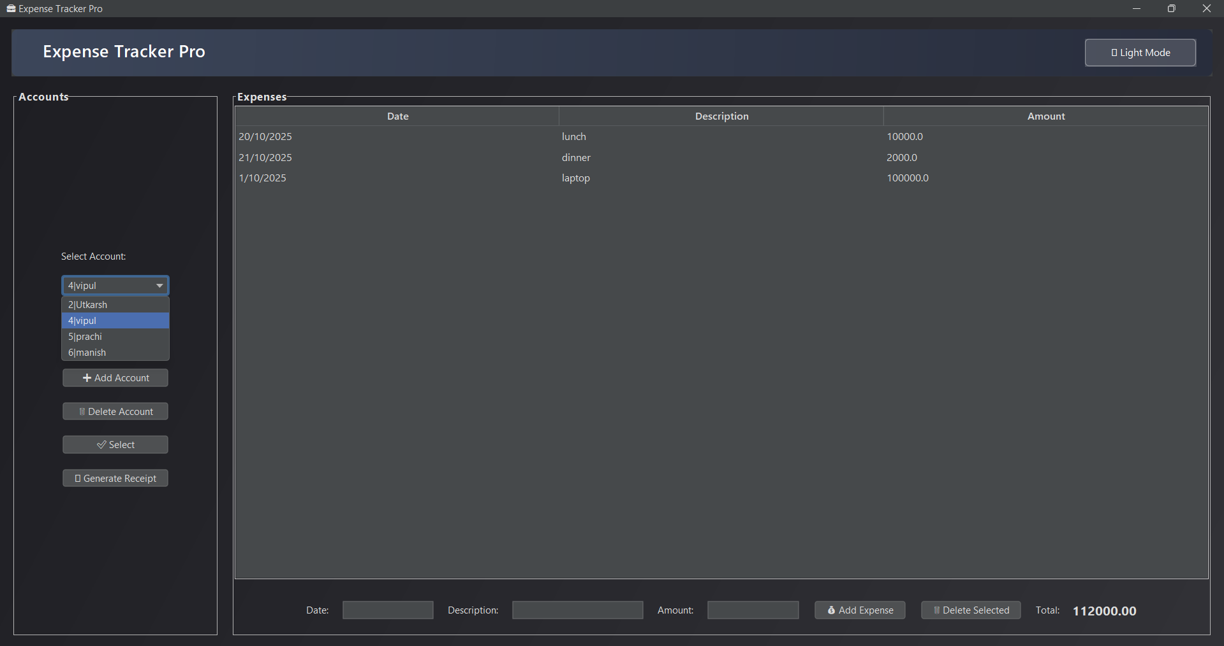

Account Dropdown
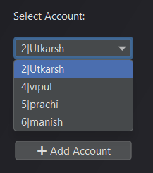

Maximize mode 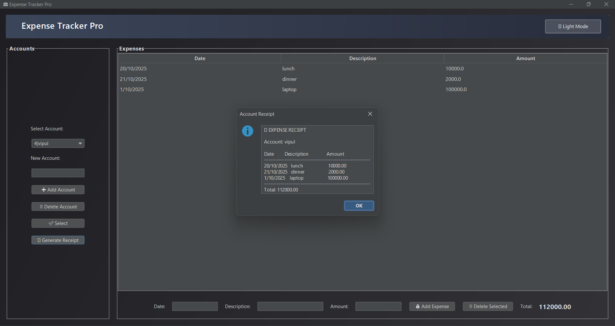
Minimise Mode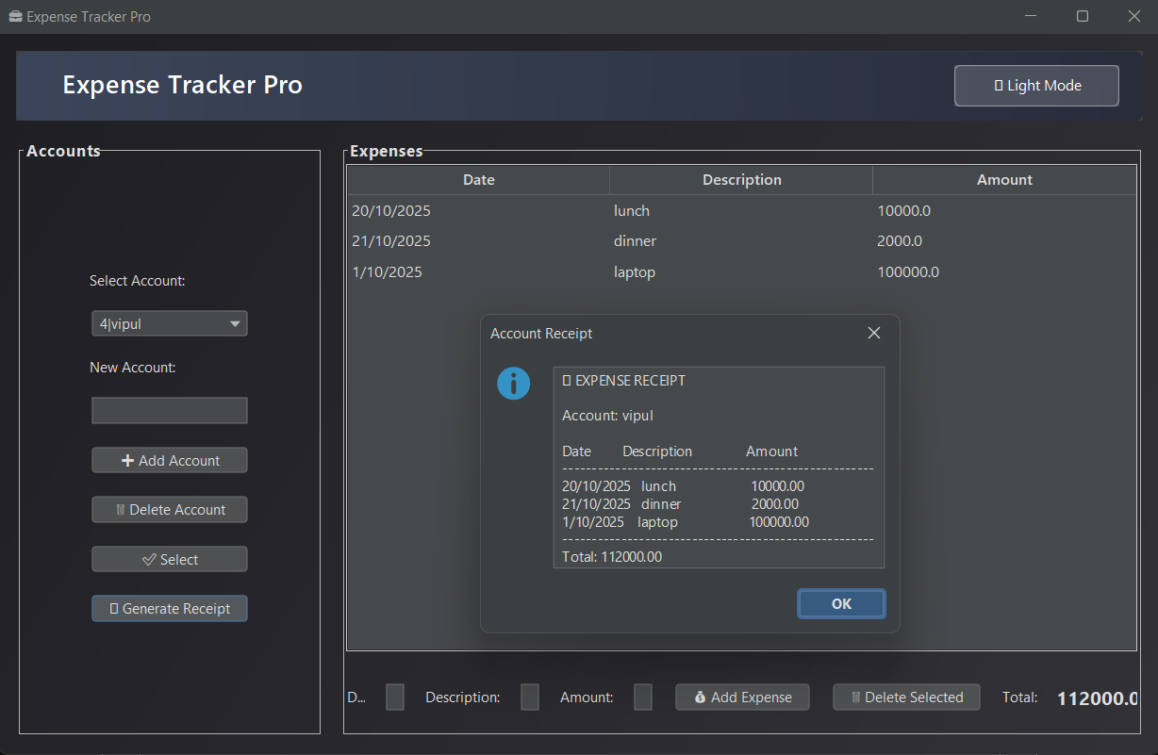

Expense Recipt
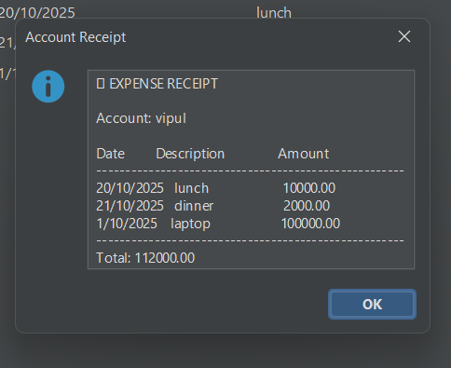
Light Mode